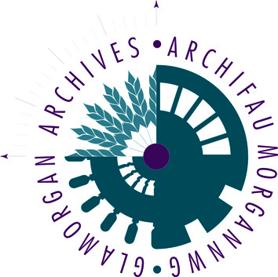
Glamorgan
Archives
Research
Application
Form

Office use only

Your contact details
Name
Address
Town |  | Post/Zip Code
Country |  | Daytime telephone number (UK only)
Email:
Please print clearly
Data Protection Act (GDPR) 2018: the information which you have provided to the Glamorgan Archives will be used to process your request for research and will not be passed to anyone else. This form will be destroyed six years after the current year and will be kept during this period for the purposes of audit.
Details of the research you require
Please provide clear and specific details of the search that you require, paying particular attention to names, places and dates. Include any details of documents/indexes already searched.

PAID RESEARCH
How to pay
Payment is made in advance; our charges are £60 per hour for private individuals (maximum 2 hours per application). The following are accepted payment methods:

- On-line payment, details on request.
- Cheque, in sterling and drawn on a British bank, made payable to Cardiff Council
- Postal Order, made payable to Cardiff Council

Please carry out 1 hour/2 hours research (delete where applicable)
I enclose payment of £…………
Signature for Authorisation of research: ………………………………………………………
Date: ………………………….
(Please note our commercial rate is £120 per hour, maximum 2 hours per application)
Copyright Declaration
(This must be signed before copies can be sent out with research)

Please supply me with the copy/copies detailed overleaf, required by me for the purposes of research or private study
I declare that-
- I have not previously been supplied with a copy of the same material by Glamorgan Archives or any other library or archive;
- I will not use the copy except for research for a non-commercial purpose or private study and will not supply a copy of it to any other person: and
- to the best of my knowledge the work had not been published before the document was deposited in the Glamorgan Archives and the copyright owner has not prohibited copying of the work (unpublished work)
or

- To the best of my knowledge no other person with whom I work or study has made or intends to make at or about the same time as this request, a request for substantially the same materials for substantially the same purpose (published work or article)

I understand that if the declaration is false in a material particular, the copy supplied to me by you will be an infringing copy, and that I shall be liable for infringement of copyright as if I had made the copy myself.

Signed: ………………………………………….
Date: …………………………………………….

Glamorgan Archives
Clos Parc Morgannwg
Leckwith
Cardiff CF11 8AW

Tel: 029 2087 2200
Email: glamro@cardiff.gov.uk
www.glamro.gov.uk

